Software Requirements Specification (SRS)
Project: AI-Powered Content Management System
Version: 1.0
Authors: < NEURAL NEXUS / Poojitha T, Bhuvanashree S, Harshitha Sai P, Sloka P>
Date: 07-10-2026

Revision history
Version | Date | Author | Change summary | Approval
1.0 | 07-10-2026 | NEURAL NEXUS | Initial SRS with use-case diagrams and RTM

Table of Contents
1. Introduction
2. Overall description
3. External interface requirements
4. System features (detailed)
5. Non-functional requirements (detailed)
5.1 Security
6. Quality attributes & Acceptance tests
7. System models and diagrams (UML Use-Case Diagrams)
8. Requirements Traceability Matrix (RTM)

1. Introduction

1.1 Purpose
This document is the Software Requirements Specification (SRS) for the AI-Powered Content Management System (AI-CMS). It defines the functional requirements, non-functional requirements, security requirements, external interfaces and verification criteria of the system. It describes what the system must do and does not describe how it is designed internally.

1.2 Scope
AI-CMS is a web-based system in which registered users upload documents (PDF, DOCX, TXT) and the system automatically extracts the text, assigns a category, extracts keywords and topics, and builds search indexes. Users find their documents using keyword search or natural-language (semantic) search, which can return relevant documents even when the query does not contain the exact words of the document. An administrator manages the category list and reviews the audit log.
The following are outside the scope of this version: optical character recognition (OCR) of scanned documents, languages other than English, sharing of documents between users, document versioning and collaborative editing, a question-answering chatbot or text generation, native mobile applications, and integration with external systems.

1.3 Audience
Developers, QA engineers, the project team, the course instructor and assessment evaluators.

1.4 Definitions
List of acronyms: AI, API, CMS, NLP, UI, REST, JSON, JWT, TLS, HTTPS, RBAC, PDF, DOCX, TXT, OCR, SRS, RTM, FR, NFR, SR.
Term | Meaning
AI-CMS | AI-Powered Content Management System, the system specified in this document.
Document | A PDF, DOCX or TXT file uploaded by a user, together with its metadata and analysis results.
Category | A named group (for example Technology) with a short description, used for automatic categorization. Categories are maintained by the Administrator.
Keyword | A word or short phrase that characterises the content of a document.
Topic | A short label that summarises a group of related keywords of a document.
Embedding | A numeric vector that represents the meaning of a piece of text; texts with similar meaning have similar vectors.
Passage | A short part of the extracted text of a document (about 150 words) for which one embedding is generated.
Semantic search | Search based on the meaning of the query, comparing its embedding with the embeddings of document passages.
Keyword search | Search based on the presence of the entered words in the title or text of a document.
Processing status | State of a document: Uploaded, Processing, Processed or Failed.
Audit log | A record of security-relevant events (for example login, upload, deletion, administrator actions).
FR / NFR / SR | Functional requirement / Non-functional requirement / Security requirement.

2. Overall description

2.1 Product perspective
AI-CMS is a self-contained web application consisting of a browser-based user interface, a server-side application and local data storage. It does not depend on any external commercial service. The AI functions (categorization, keyword and topic extraction, embedding generation) use pre-trained open-source language models that run on the server itself, so uploaded documents are not sent to third parties. The system has no connection to other existing systems.

2.2 Major product functions (detailed)
- User registration, login, logout and role-based access (User, Administrator)
- Document upload with file validation, storage and metadata
- Document list, detail view, download, title/category editing and deletion
- Automatic text extraction from PDF, DOCX and TXT files
- Automatic categorization of documents into administrator-defined categories
- Automatic extraction of keywords and topics
- Generation of embeddings and indexes to support search
- Keyword search and natural-language (semantic) search with ranking and snippets
- Search filters by category, file type and upload date
- Administration: category list (predefined categories, add, delete) and audit log

2.3 User roles and characteristics (expanded)
- Visitor (not logged in): can only register and log in.
- User: a student or staff member with basic computer skills who manages his or her own documents and searches them. Expects results in a few seconds and simple screens.
- Administrator: manages the category list and reviews the audit log. Has no access to the content of other users' documents.

2.4 Operating environment
Server: Windows 10/11 or Ubuntu 22.04 (at least one), Python 3.10 or later, a typical laptop or PC with about 4 CPU cores, 8 GB RAM and about 5 GB free disk space, no GPU required. This configuration is the reference environment used for the performance targets in Section 5. Client: desktop or laptop with the latest Google Chrome (other modern browsers are expected to work but are not required) and a screen width of at least 1280 pixels. Network: local network or internet; the server needs internet access only once, to download the pre-trained models during installation.

2.5 Constraints
- Only free and open-source software and no paid external APIs may be used.
- All AI processing runs locally on the server without a GPU.
- Only English-language, text-based documents are supported; scanned documents are not processed.
- Maximum upload size is 10 MB per file. The system is designed for up to about 100 documents and about 5 concurrent users.
- The system is deployed on a single server; distributed deployment is not required.
- The system must be completed within the semester schedule of the course by a student team.

3. External interface requirements

3.1 User interfaces
Primary UI: a web application with the following pages: Login/Register; Document List with upload form; Document Details; Search with filters and result list; and, for the Administrator, Categories and Audit Log. Messages shall be shown for success, validation errors and processing status. Accessibility: every form field has a text label, and forms can be used with the keyboard (see NFR-005).

3.2 Hardware interfaces
No special hardware is required. The server is a standard PC or laptop (see Section 2.4). Clients use a standard keyboard, mouse or touch pad and a display.

3.3 Software interfaces
- Pre-trained sentence-embedding language model (open source), used through a Python library on the server to generate embeddings.
- Relational database with full-text search capability for users, document metadata, extracted text, keywords, topics, categories and audit log.
- Vector store library for saving and querying passage embeddings.
- Text-extraction libraries for PDF, DOCX and TXT files.
- Local file system folder for storing the original uploaded files.
- Web browser (Google Chrome) as the client of the REST API.

3.4 Communications
- Browser and server communicate over HTTPS (TLS 1.2 or higher) using a REST API with JSON messages; file upload uses multipart form data (SR-001).
- The access token is sent in the Authorization header of every request after login (SR-003).
- Long-running document processing runs in the background; the browser checks the document status by periodic requests.
Summary of requirements in this document: 25 functional requirements (FR-001 to FR-025), 8 non-functional requirements (NFR-001 to NFR-008), 3 security objectives (SO-1 to SO-3) and 8 security requirements (SR-001 to SR-008).

4. System features (detailed)
Each requirement below includes acceptance criteria and a reference test case. IDs follow FR-###. The Type column is Functional for all requirements of this section. Priority is High, Medium or Low.

4.1 Authentication and Access Control
Description: Register and authenticate users, end sessions and restrict access according to role and ownership.
Req ID | Requirement (shall...) | Type | Priority | Source / Stakeholder | Acceptance criteria / Test case ref | Comments / Dependencies
FR-001 | The system shall allow a visitor to register an account by providing a unique username, a valid email address and a password of at least 8 characters containing at least one letter and one digit. | Functional | High | End User | AC-FR-001: Valid details create an account with role User. A duplicate username/email, invalid email or weak password is rejected with a message naming the problem.  Test: TC-Auth-01, TC-Auth-02 | Self-registration creates only the User role.
FR-002 | The system shall authenticate a registered user using username and password and shall issue an access token on success. | Functional | High | End User / Security | AC-FR-002: Correct credentials return a token and open the document list. Wrong credentials are rejected with a generic message that does not reveal which field was wrong.  Test: TC-Auth-03, TC-Auth-04 | Depends on FR-001.
FR-003 | The system shall allow a logged-in user to log out and shall invalidate the access token on logout and automatically 30 minutes after it was issued. | Functional | High | Security | AC-FR-003: A token used after logout or after 30 minutes is rejected and the user is redirected to the login page.  Test: TC-Auth-05, TC-Auth-06 | Depends on FR-002.
FR-004 | The system shall support two roles, User and Administrator. A User shall be able to view, download, edit, delete and search only the documents that the User owns, and administrative functions shall be available only to an Administrator. | Functional | High | Security / Admin | AC-FR-004: A request for another user's document is refused and discloses no content. Search results contain only the requester's documents. A User calling an administrative function is refused.  Test: TC-Auth-07, TC-Auth-08, TC-Srch-09 | Administrator accounts are created by seeding, not by self-registration.

4.2 Document Management
Description: Accept uploaded documents after validation, store them with metadata and let the owner list, view, download, edit and delete them.
Req ID | Requirement (shall...) | Type | Priority | Source / Stakeholder | Acceptance criteria / Test case ref | Comments / Dependencies
FR-005 | The system shall allow an authenticated user to upload one document at a time in PDF, DOCX or TXT format through the web interface, with an optional title (default: the file name). | Functional | High | End User | AC-FR-005: A valid file is accepted, appears in the user's list and processing starts automatically.  Test: TC-Doc-01 | Depends on FR-002.
FR-006 | The system shall validate each uploaded file before storing it: the extension must be .pdf, .docx or .txt, the file content must match the extension, the size must be greater than 0 and not more than 10 MB. An invalid file shall be rejected with a specific error message and shall not be stored. | Functional | High | Security | AC-FR-006: Files of unsupported type, over 10 MB, empty, or with content not matching the extension are rejected with a message and no record or file is created.  Test: TC-Doc-02, TC-Doc-03, TC-Doc-04 | See also SR-005.
FR-007 | The system shall store the original file and shall record the metadata of each document: title, original file name, file type, file size, owner, upload date and time, and processing status. | Functional | High | System | AC-FR-007: After upload, all metadata fields are present in the database and the stored file is identical to the uploaded file.  Test: TC-Doc-05
FR-008 | The system shall display the user's documents in a paginated list of 10 documents per page showing title, file type, category, processing status and upload date, sortable by upload date and by title. | Functional | High | End User | AC-FR-008: The list shows only the user's own documents; page navigation and both sort options work.  Test: TC-Doc-06, TC-Doc-07
FR-009 | The system shall display the details of a document: its metadata, assigned category with confidence score, keywords, topics, processing status (with the failure reason if any) and a preview of the first 1000 characters of the extracted text. | Functional | High | End User | AC-FR-009: All listed items are shown for a Processed document; a Failed document shows its failure reason.  Test: TC-Doc-08 | Depends on FR-013 to FR-017.
FR-010 | The system shall allow the owner to download the original file of a document. | Functional | Medium | End User | AC-FR-010: The downloaded file has the same checksum and original file name as the uploaded file.  Test: TC-Doc-09
FR-011 | The system shall allow the owner to delete a document after confirmation. Deletion shall remove the stored file, metadata, extracted text, keywords, topics and search index entries of the document. | Functional | High | End User | AC-FR-011: After deletion the document is absent from the list and from keyword and semantic search results, and its file and embeddings no longer exist.  Test: TC-Doc-10, TC-Doc-11 | Deletion is permanent (no recycle bin).
FR-012 | The system shall allow the owner to change the title of a document and to manually assign a different category from the existing category list. A manually assigned category shall be marked as manual and shall not be overwritten by later processing. | Functional | Medium | End User | AC-FR-012: The new title and category are shown everywhere the document appears. After reprocessing, a manual category is unchanged.  Test: TC-Doc-12, TC-Doc-13 | Allows the user to correct wrong AI categories.

4.3 Document Processing and AI Analysis
Description: Automatically analyse each uploaded document: extract the text, assign a category, extract keywords and topics, and generate embeddings and indexes for search.
Req ID | Requirement (shall...) | Type | Priority | Source / Stakeholder | Acceptance criteria / Test case ref | Comments / Dependencies
FR-013 | The system shall extract plain text from uploaded PDF (text-based), DOCX and TXT files. If no text can be extracted (for example scanned, corrupted or password-protected PDF), the document status shall be set to Failed with a readable reason. | Functional | High | System | AC-FR-013: Text from sample PDF, DOCX and TXT files is extracted completely enough for later steps. Scanned/corrupted/protected PDFs end as Failed with a reason.  Test: TC-AI-01, TC-AI-02, TC-AI-03 | OCR is out of scope.
FR-014 | The system shall start processing of a document automatically after a successful upload without making the user wait, and shall maintain and display a processing status of Uploaded, Processing, Processed or Failed. | Functional | High | End User | AC-FR-014: The upload request is answered before processing finishes. The status moves Uploaded, Processing, Processed (or Failed) and is visible in the list.  Test: TC-AI-04 | Depends on FR-005.
FR-015 | The system shall automatically assign each processed document exactly one category from the category list, together with a confidence score. If the best score is below a configurable threshold the category shall be Uncategorized. | Functional | High | End User / Course requirement | AC-FR-015: Sample documents of each default category receive the expected category. A document unrelated to all categories receives Uncategorized.  Test: TC-AI-05, TC-AI-06 | Overall accuracy target: NFR-003.
FR-016 | The system shall extract up to 10 keywords or key phrases from each processed document, ordered by relevance, and store them with the document. | Functional | High | End User / Course requirement | AC-FR-016: Each processed document has 1 to 10 keywords, ordered by score, none consisting only of stop words.  Test: TC-AI-07
FR-017 | The system shall identify up to 3 topic labels for each processed document, where each topic label summarises a group of related keywords of the document. | Functional | Medium | End User / Course requirement | AC-FR-017: Each processed document has 1 to 3 topic labels and each label is one of the document's key phrases.  Test: TC-AI-08 | Depends on FR-016.
FR-018 | The system shall divide the extracted text into passages, generate a vector embedding for each passage and store the embeddings with the document identifier for semantic search. The system shall also index the extracted text for keyword search. | Functional | High | System | AC-FR-018: After processing, the vector index holds embeddings for the document's passages and the keyword index returns the document for a word found in its text.  Test: TC-AI-09 | Required by FR-020 and FR-021.
FR-019 | The system shall allow the owner to reprocess a Failed or Processed document. New results shall replace the earlier category, keywords, topics and embeddings. | Functional | Medium | End User | AC-FR-019: After reprocessing, the document shows new results and no duplicate index entries remain.  Test: TC-AI-10 | Also used after the administrator changes categories.

4.4 Search
Description: Let users find their documents with keyword or natural-language queries, ranked by relevance and restricted by filters.
Req ID | Requirement (shall...) | Type | Priority | Source / Stakeholder | Acceptance criteria / Test case ref | Comments / Dependencies
FR-020 | The system shall provide keyword search that returns the user's Processed documents whose title or extracted text contains all entered terms, ignoring letter case. | Functional | High | End User / Course requirement | AC-FR-020: A query of terms present in a document returns that document. A query with a term not present returns an empty result with a message.  Test: TC-Srch-01, TC-Srch-02 | Depends on FR-018.
FR-021 | The system shall accept a natural-language query of 3 to 300 characters and shall return the user's Processed documents that are semantically relevant to the query, including documents that do not contain the words of the query. | Functional | High | End User / Course requirement | AC-FR-021: For the predefined test queries, the expected document appears in the top 5 results even when the query words are absent from it. Queries shorter than 3 or longer than 300 characters are rejected with a message.  Test: TC-Srch-03, TC-Srch-04, TC-Srch-10 | Overall quality target: NFR-004.
FR-022 | The system shall present search results in descending order of relevance, 10 results per page, showing for each result the title, category, file type, upload date, a text snippet from the matching part of the document and, for natural-language search, a relevance score as a percentage. Results below a configurable minimum relevance shall be omitted. | Functional | High | End User | AC-FR-022: Results are ordered by relevance, paginated, and each result shows the listed items.  Test: TC-Srch-05, TC-Srch-06
FR-023 | The system shall allow the user to restrict search results by category, file type and upload date range, and shall apply several selected filters together. | Functional | Medium | End User | AC-FR-023: Each filter, and any combination, returns only documents that satisfy all selected filters.  Test: TC-Srch-07, TC-Srch-08 | Applies to both search modes.

4.5 Administration
Description: Allow the Administrator to maintain the category list and to review the audit log.
Req ID | Requirement (shall...) | Type | Priority | Source / Stakeholder | Acceptance criteria / Test case ref | Comments / Dependencies
FR-024 | The system shall provide six predefined categories at installation and shall allow an Administrator to add a new category (name and short description) and to delete a category. Deleting a category shall set its documents to Uncategorized. | Functional | Medium | Admin | AC-FR-024: The six predefined categories exist after installation. An added category appears in the category list and is used for documents processed afterwards. After a category is deleted its documents show Uncategorized.  Test: TC-Adm-01, TC-Adm-02 | Existing documents change category only when reprocessed (FR-019).
FR-025 | The system shall allow an Administrator to view the audit log of recorded events, latest first, in pages of 10 entries. | Functional | Medium | Admin / Security | AC-FR-025: The audit log shows time, user, action and details of events, newest first, with page navigation.  Test: TC-Adm-03 | Audit events are defined in SR-007.

5. Non-functional requirements (detailed)
NFRs below are measurable and tied to the test plan. IDs follow NFR-###. Performance values apply to the reference environment in Section 2.4.
Req ID | Requirement | Category | Priority | Acceptance criteria / Measurement
NFR-001 | Search (keyword or natural-language) shall return the first page of results within 5 seconds for 90% of queries, with up to 100 documents stored, on the reference environment given in Section 2.4. | Performance | High | 90th percentile response time at or below 5 s over 20 test queries. Test: TC-Perf-01
NFR-002 | Processing of a document of up to 20 pages (about 10,000 words) shall complete within 2 minutes on the reference environment. | Performance | Medium | At least 4 of 5 test documents reach Processed within 2 minutes. Test: TC-Perf-02
NFR-003 | Automatic categorization shall assign the correct default category to at least 60% of a labelled test set of at least 20 English documents (at least 3 per default category). | AI Quality | Medium | Accuracy = correct / total >= 0.60. Test: TC-Eval-01
NFR-004 | For a predefined set of at least 10 natural-language queries, each with at least one known relevant document, a relevant document shall appear in the top 5 results for at least 60% of the queries. | AI Quality | Medium | Hit rate at 5 >= 0.60. Test: TC-Eval-02
NFR-005 | A first-time user shall be able to register, upload a document and find it by search without instructions within 10 minutes (at least 2 of 3 test participants). All form fields shall have text labels. | Usability | Medium | Usability task test and UI checklist. Tests: TC-UX-01, TC-UX-02
NFR-006 | A failure while processing one document shall not stop the application or affect other requests. After a server restart, no document shall remain in Processing status. | Reliability | Medium | Corrupted file test and restart test pass. Tests: TC-Rel-01, TC-Rel-02
NFR-007 | The back-end shall be organised into separate modules for API, services and data access, and automated unit tests shall cover at least 50% of the lines of the service layer. | Maintainability | Low | Coverage report >= 50%. Test: TC-Maint-01
NFR-008 | The system shall run on Windows 10/11 or Ubuntu 22.04 (at least one of them, with setup steps in the README) using only free software, and the web interface shall work on the latest version of Google Chrome. | Portability / Compatibility | Low | Installation from the README succeeds on the team's operating system; main flows work in Chrome. Tests: TC-Port-01, TC-UX-03

5.1. Security

5.1.1 Security Objectives
ID | Objective | Description
SO-1 | Confidentiality of documents | Document content and metadata shall be readable only by the user who owns the document, and shall not be disclosed to other users through the document list, details, download or search functions.
SO-2 | Integrity of the system and its data | The system shall accept only valid, expected input (files, queries, form data) so that malicious files or input cannot damage stored data or the application.
SO-3 | Authentication and accountability | Only registered users shall access the system, and security-relevant actions shall be recorded so that they can be reviewed by an Administrator.

5.1.2 Security Requirements
Req ID | Requirement (shall...) | Type | Priority | Acceptance criteria / Test case ref
SR-001 | All communication between the browser and the server shall use HTTPS with TLS 1.2 or higher in the deployed system. | Security | High | Only TLS 1.2+ is accepted by the deployed instance. Test: TC-Sec-01
SR-002 | Passwords shall be stored only as salted bcrypt hashes and shall never be written to logs or returned in any response. | Security | High | Database shows hashes only; logs and responses contain no password. Test: TC-Sec-02
SR-003 | Every endpoint except registration, login and the health check shall require a valid, unexpired access token; otherwise the request shall be refused with status 401. | Security | High | Missing, tampered or expired tokens are refused. Tests: TC-Sec-03, TC-Sec-04
SR-004 | Ownership and role checks shall be performed on the server for every document, search and administrative request, independent of what the user interface shows. | Security | High | Direct requests for other users' documents or admin functions are refused. Tests: TC-Sec-05, TC-Sec-06
SR-005 | Uploaded files shall be checked for extension, content signature and size, stored under system-generated names outside any publicly served folder, and the original file name shall be sanitised before it is stored or displayed. | Security | High | Renamed executables and path-traversal names are rejected or neutralised; stored names are generated. Tests: TC-Sec-07, TC-Sec-08
SR-006 | All database access shall use parameterised queries, all inputs shall be validated for type and length, and all user-supplied text shall be output-encoded in the web interface. | Security | High | SQL injection and script payloads have no effect. Tests: TC-Sec-09, TC-Sec-10
SR-007 | The system shall record in an audit log the events: login success, login failure, logout, document upload, document deletion and administrator actions, each with time, user and action, and shall not record passwords, tokens or document text. | Security | Medium | Each listed event creates one entry; entries contain no sensitive data. Test: TC-Sec-11
SR-008 | The token signing key and other secrets shall be read from environment configuration and shall not be stored in source code or in the repository. | Security | Medium | Repository scan shows no secrets; application fails to start without the key. Test: TC-Sec-12

Relation of the security requirements to the objectives: SO-1 is supported by FR-004, SR-003 and SR-004; SO-2 by FR-006, SR-005 and SR-006; SO-3 by FR-002, SR-002, SR-003 and SR-007. SR-001 and SR-008 protect all three objectives.

6. Quality attributes & Acceptance tests

6.1 Quality attributes
Quality attribute | Related requirements | How it is measured
Performance | NFR-001, NFR-002 | Response time and processing time on the reference environment (TC-Perf-01, TC-Perf-02)
Accuracy of AI functions | FR-015, FR-021, NFR-003, NFR-004 | Accuracy and top-5 hit rate on labelled test sets (TC-Eval-01, TC-Eval-02)
Security | FR-004, SR-001 to SR-008 | Security test cases TC-Sec-01 to TC-Sec-12
Usability | NFR-005 | Task-based test with 3 participants and a UI checklist (TC-UX-01, TC-UX-02)
Reliability | NFR-006, FR-014 | Failure-isolation and restart tests (TC-Rel-01, TC-Rel-02)
Maintainability | NFR-007 | Unit test coverage report (TC-Maint-01)
Portability and compatibility | NFR-008 | Installation on the team's operating system and use in Chrome (TC-Port-01, TC-UX-03)

6.2 Acceptance
- Exit criteria for acceptance: all High-priority functional requirements implemented and verified, NFR-001 to NFR-004 targets met, no critical or high-severity defect open, and the RTM shows all test cases passed.
- Acceptance test suites: Authentication and Access Control, Document Management, AI Processing, Search, Administration, Performance, Security, and Usability.

7. System models and diagrams

7.1 UML Use-Case diagram
Three use-case diagrams are given. In all diagrams a user must be logged in before using the use cases, except Register and Log In.
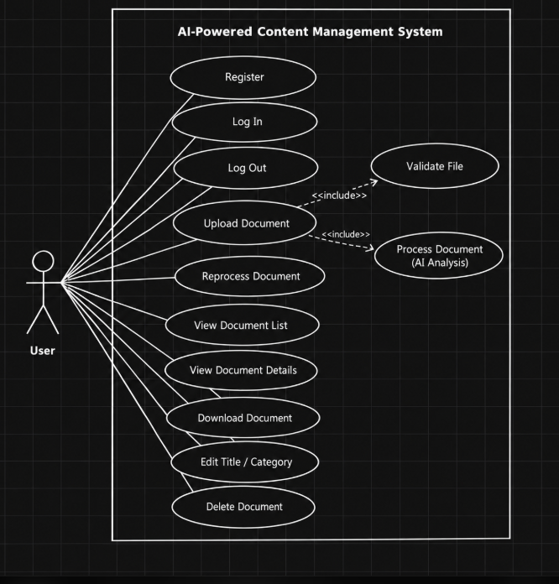
Figure 1: Use-case diagram - Authentication and Document Management (FR-001 to FR-014, FR-019)
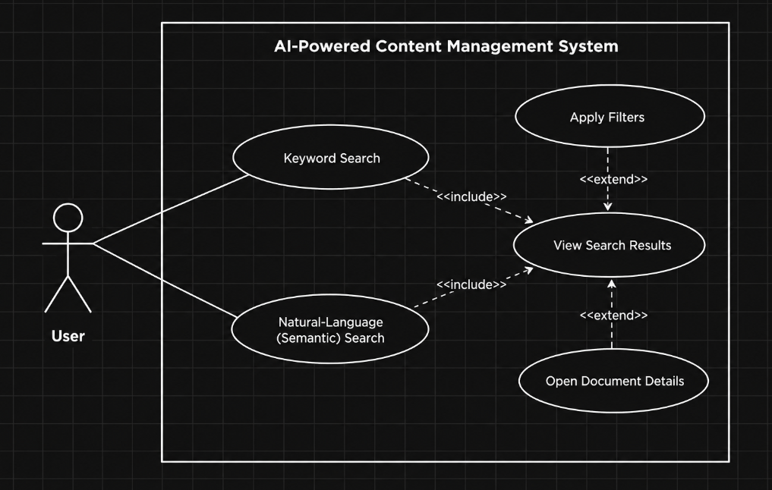
Figure 2: Use-case diagram - Document Search (FR-020 to FR-023)
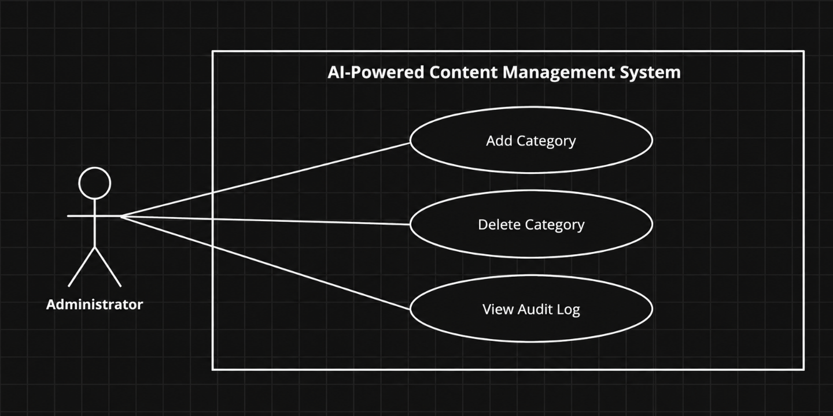
Figure 3: Use-case diagram - Administration (FR-024, FR-025)

8. Requirements Traceability Matrix (RTM)
Status: N = not yet implemented, P = partially implemented, A = implemented and accepted. Design Spec IDs (DS-...) refer to the Software Architecture and Design Specification of the same project. Test case IDs are defined in the Software Test Plan.
Req ID | Requirement short | Section ref / Design Spec | Module | Test case(s) | Status (N/P/A) | Comments
FR-001 | User registration | 4.1 / DS-Auth-01 | Auth Service | TC-Auth-01, TC-Auth-02 | N
FR-002 | User login | 4.1 / DS-Auth-01 | Auth Service | TC-Auth-03, TC-Auth-04 | N
FR-003 | Logout and session expiry | 4.1 / DS-Auth-01 | Auth Service | TC-Auth-05, TC-Auth-06 | N
FR-004 | Role-based access control | 4.1 / DS-Auth-02 | Auth Service | TC-Auth-07, TC-Auth-08, TC-Srch-09 | N
FR-005 | Document upload | 4.2 / DS-Doc-01 | Document Service | TC-Doc-01 | N
FR-006 | File validation | 4.2 / DS-Doc-01 | Document Service | TC-Doc-02, TC-Doc-03, TC-Doc-04 | N
FR-007 | Document storage and metadata | 4.2 / DS-Doc-01 | Document Service | TC-Doc-05 | N
FR-008 | Document list | 4.2 / DS-Doc-01 | Document Service | TC-Doc-06, TC-Doc-07 | N
FR-009 | View document details | 4.2 / DS-Doc-01 | Document Service | TC-Doc-08 | N
FR-010 | Download document | 4.2 / DS-Doc-01 | Document Service | TC-Doc-09 | N
FR-011 | Delete document | 4.2 / DS-Doc-01 | Document Service | TC-Doc-10, TC-Doc-11 | N
FR-012 | Edit title and category | 4.2 / DS-Doc-01 | Document Service | TC-Doc-12, TC-Doc-13 | N
FR-013 | Text extraction | 4.3 / DS-Proc-02 | Text Extractor | TC-AI-01, TC-AI-02, TC-AI-03 | N
FR-014 | Automatic processing and status | 4.3 / DS-Proc-01 | Processing Pipeline | TC-AI-04 | N
FR-015 | Automatic categorization | 4.3 / DS-Proc-03 | Categorizer | TC-AI-05, TC-AI-06 | N
FR-016 | Keyword extraction | 4.3 / DS-Proc-04 | Keyword & Topic Extractor | TC-AI-07 | N
FR-017 | Topic extraction | 4.3 / DS-Proc-04 | Keyword & Topic Extractor | TC-AI-08 | N
FR-018 | Embedding generation and indexing | 4.3 / DS-Proc-05 | Embedding Generator | TC-AI-09 | N
FR-019 | Reprocess document | 4.3 / DS-Proc-01 | Processing Pipeline | TC-AI-10 | N
FR-020 | Keyword search | 4.4 / DS-Srch-01 | Search Service | TC-Srch-01, TC-Srch-02 | N
FR-021 | Natural-language semantic search | 4.4 / DS-Srch-02 | Search Service | TC-Srch-03, TC-Srch-04, TC-Srch-10 | N
FR-022 | Result ranking and presentation | 4.4 / DS-Srch-03 | Search Service | TC-Srch-05, TC-Srch-06 | N
FR-023 | Search filters | 4.4 / DS-Srch-03 | Search Service | TC-Srch-07, TC-Srch-08 | N
FR-024 | Category management | 4.5 / DS-Adm-01 | Admin Service | TC-Adm-01, TC-Adm-02 | N
FR-025 | Audit log view | 4.5 / DS-Adm-02 | Admin Service | TC-Adm-03 | N
NFR-001 | Search response time | 5 / DS-Srch-02 | Search Service | TC-Perf-01 | N
NFR-002 | Document processing time | 5 / DS-Proc-01 | Processing Pipeline | TC-Perf-02 | N
NFR-003 | Categorization accuracy | 5 / DS-Proc-03 | Categorizer | TC-Eval-01 | N
NFR-004 | Semantic search relevance | 5 / DS-Srch-02 | Search Service | TC-Eval-02 | N
NFR-005 | Usability | 5 / DS-UI-01 | Web UI | TC-UX-01, TC-UX-02 | N
NFR-006 | Reliability and error recovery | 5 / DS-Proc-01 | Processing Pipeline | TC-Rel-01, TC-Rel-02 | N
NFR-007 | Maintainability | 5 / DS-Cfg-01 | All back-end modules | TC-Maint-01 | N
NFR-008 | Portability and compatibility | 5 / DS-Cfg-01 | Web UI / Back-end | TC-Port-01, TC-UX-03 | N
SR-001 | TLS for all connections | 5.1.2 / DS-Cfg-01 | Deployment configuration | TC-Sec-01 | N
SR-002 | Password protection | 5.1.2 / DS-Auth-01 | Auth Service | TC-Sec-02 | N
SR-003 | Token authentication | 5.1.2 / DS-Auth-01 | Auth Service / API Layer | TC-Sec-03, TC-Sec-04 | N
SR-004 | Server-side authorization | 5.1.2 / DS-Auth-02 | Auth Service / API Layer | TC-Sec-05, TC-Sec-06 | N
SR-005 | Safe file upload | 5.1.2 / DS-Doc-01 | Document Service | TC-Sec-07, TC-Sec-08 | N
SR-006 | Injection protection | 5.1.2 / DS-Sec-01 | API Layer / Data Access Layer / Web UI | TC-Sec-09, TC-Sec-10 | N
SR-007 | Audit logging | 5.1.2 / DS-Aud-01 | Audit Logger | TC-Sec-11 | N
SR-008 | Secret management | 5.1.2 / DS-Cfg-01 | Configuration | TC-Sec-12 | N

